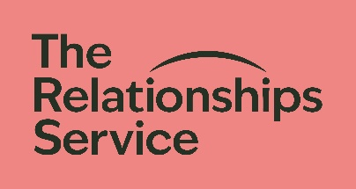 Leaving a gift in your Will
We would really like to say thank you if you have included The Relationships Service in your Will. A gift in a Will, however big or small, makes a real difference to the relationships of the adults, children, young people and families we work with.

If you are happy to share your details with us the information you provide will be treated confidentially:

I have included The Relationships Service in my Will

I intend to include The Relationships Service in my Will
Your details
Your full name:
Home address:
Postcode: |  | Email:
Home tel no: |  | Mobile:
Please send your form to:
info@relationships-service.org.uk

The Relationships Service
The Gables
St. Mary’s Road
Hemel Hempstead
HP2 5HL
THANK YOU FOR YOUR SUPPORT
A company limited by guarantee. Registered in England 3141164. Registered Charity No. 1053223

